String Concatenation in Java:

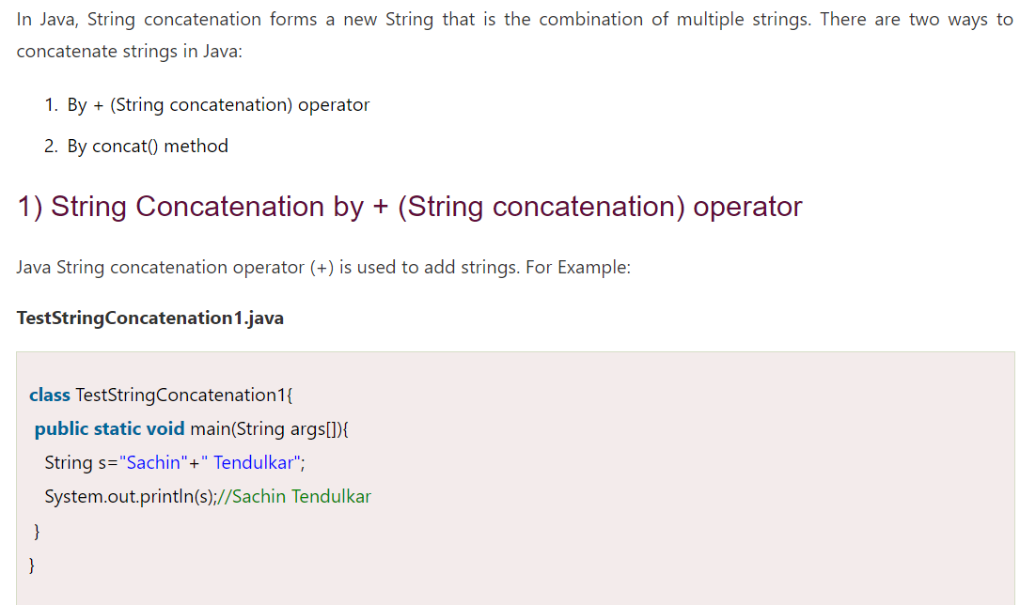

**String concatenation using StringBuilder class:**

**String concatenation using format() method:**

**String concatenation using String.join() method (Java Version 8+):**

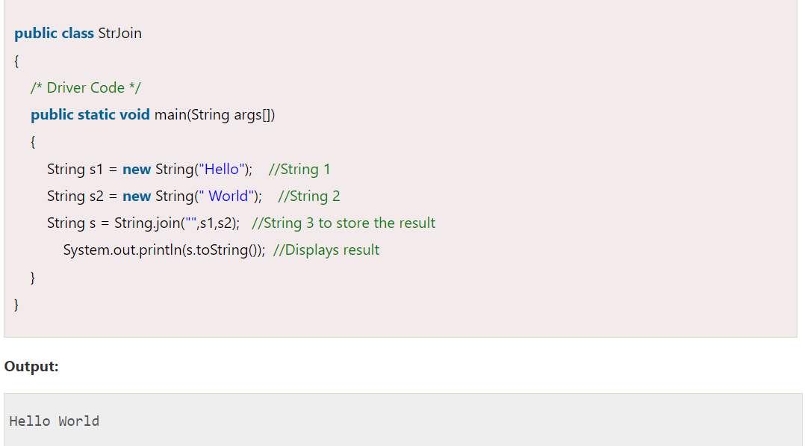

**String concatenation using StringJoiner class (Java Version 8+):**

**String concatenation using Collectors.joining() method (Java (Java Version 8+):**

